TELUS PureFibre™ Build

Throughout 2023 and 2024, TELUS will be working in local neighbourhoods to connect The Town of High Level, parts of Mackenzie County (Ft Vermilion & La Crete) and the M.D. of Opportunity (Red Earth Creek) to the TELUS PureFibre™ network - Canada’s #1 internet technology for speed and reliability.¹

About the project
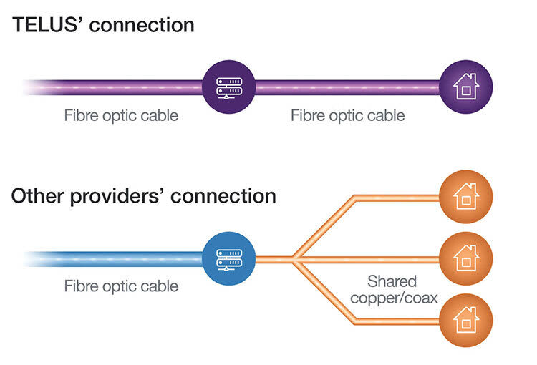
The TELUS PureFibre network is made up of flexible, transparent, durable strands of glass. These fibre optic strands transmit information as pulses of light, and carry huge amounts of information in the space of seconds.

TELUS is the only major provider in Western Canada with a 100% fibre optic connection to the home¹. That means a fast, always consistent connection. Connecting your community to the TELUS PureFibre™ network means that you will have access to the unique opportunities that fibre optic internet brings to residents, businesses, organizations, and essential services. Visit telus.com/connectme today to connect your home or business. Then, once construction is complete, we’ll contact you to switch to the TELUS PureFibre network.

Location and Impacts
The majority of construction will take place on public boulevards and utility rights-of-way. In cases where some work needs to take place on private property, TELUS will send out communications to all homeowners in the construction area.
To learn more about the construction process click here to access Videos and FAQs

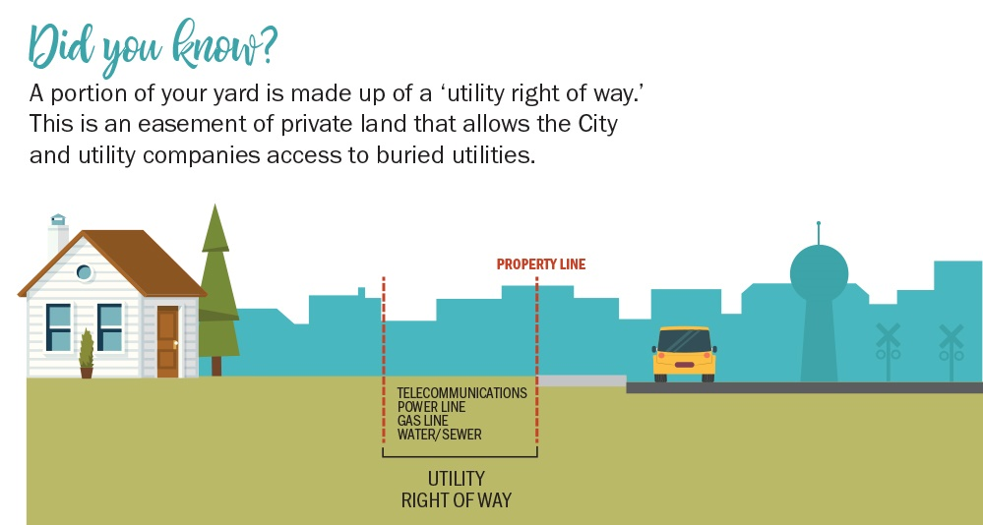

2023 Project
The build project is anticipated to run throughout the year of 2023/2024 with the first neighborhoods ready for service sometime in 2024.

Spring Restoration

Part of TELUS’ overall community investment is ensuring the restoration of all property to the same condition it was in prior to construction. This can include soft surface restoration such as leveling with new topsoil and planting grass seed. In places where hard surfaces are impacted, such as concrete or asphalt driveways, TELUS will always fill and repair an impact afterwards. Some restoration may have to wait until spring as this work is weather dependent, and will resume as soon as the ground conditions permit.

Reseeding
Once the TELUS PureFibre install is complete, reseeding will take place in all impacted areas. Click here for detailed watering instructions for newly reseeded property.

General guidelines:
- Keep the reseeded area lightly watered until the grass is established. This may include watering several times daily, being careful not to over-water as the seeds can rot.
- Try to stay off the reseeded areas.
- Do not cut or rake the reseeded areas until the new grass has matured - give the grass time to grow.

Contact Information:
In the community of La Crete, High Level or Ft Vermilion if you have any questions or concerns regarding construction, please contact:  Ledcor  telusfibrecommunity@ledcor.com  1-800-689-6631 | In the community of Red Earth, if you have any questions or concerns regarding construction, please contact:  AFL Global  abcustomercare@aflglobal.com  1-844-343-1222

- Traditional copper wire or copper wire hybrid networks are subject to capacity constraints and environmental stresses that do not affect TELUS fibre optic technology, which is based on light signals. Not available in all areas. Individual results may vary depending on location, usage within the home network, Internet traffic, applicable network management or server configurations. For a description of TELUS’ network management practices please see telus.com/networkmanagement

